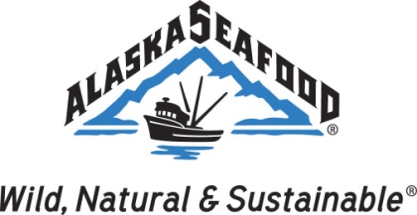
SEAFOOD TECHNICAL COMMITTEE
Tuesday, October 30, 2018
10:00 AM AKST
Captain Cook Hotel
Voyager Room
Anchorage, Ak
Call in number: 800-315-6338 Alternate call in number: +1-913-904-9376 Access Code: 87904
DRAFT AGENDA
I Roll Call
II Approval of Draft Agenda
III Approval of February 2018 Meeting Minutes
IV Public Comment
V Introduction of invited members
VI Good of the order
- Alaska Ocean Cluster update- Joel Cladouhos
- KSMSC update- Chris Sannito
VII Old Business (please refer to notes)
- Chitosan/Listeria RTE Crab project - Michael
- PCCRC project - Dr. Christina Dewitt
- Alaska salmon omega 3 and breast cancer survivors (SiRF/UConn) – Michael
- Quality video content review
- Chalky halibut
- Nutritionist
IX New Business
- Update on collaborations with other ASMI programs
- Quality material plans
- Seafood contaminant database
- Alaska seafood nutrition analyses/USDA overview
- Roe (caviar) nutrition quality material
- Smoked seafood brochure/online pdf
- Future possible areas of interest
  - 2019 Kodiak intern project
  - Specialty products FAM trip
X Adjournment

