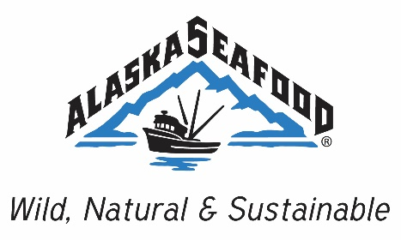

ASMI Salmon Committee Meeting
Wednesday, April 19, 2017
Beginning at 8:00AM Alaska Time
TBD Room at the Captain Cook in Anchorage AK

Dial-In Information
Call in number: 800-315-6338
Alternate Call in number: 1-913-904-9376
Access Code: 37152

Draft Agenda

Roll call

Approval of draft agenda

Approval of the minutes from previous meeting

Public Comment

Old business and good of the order

2017 salmon season and update – Andy Wink, McDowell Group

Ongoing salmon marketing campaigns

Update on Canadian Markets

Final Comments

Schedule next meeting

Adjourn

