DRAFT AGENDA
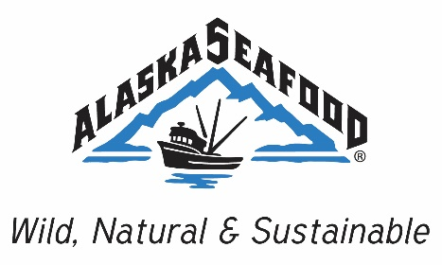
ASMI Domestic Marketing Committee Meeting
Friday, October 13, 2017
11:00 AM – 12:30 PM PDT
Teleconference

Dial-In Information
Toll-Free Number: 800-315-6338
Alternate Number: 913-904-9376
Access Code: 37152

- Call to Order
- Roll Call
- Approval of Agenda
- Approval of Minutes from the 4/18/17 Committee Meeting
- Public Comment
- Executive Director Update – Alexa Tonkovich
a. State Budget, Staffing, and Office Update
- Communications/Consumer PR Update – Jeremy Woodrow
a. Communication Program Plan
- Domestic Marketing Program Update – Victoria Parr
- Old Business and Good of the Order
- Next Meeting: All Hands, November 28-30, 2017, Captain Cook Hotel, Anchorage, AK
- Adjourn

