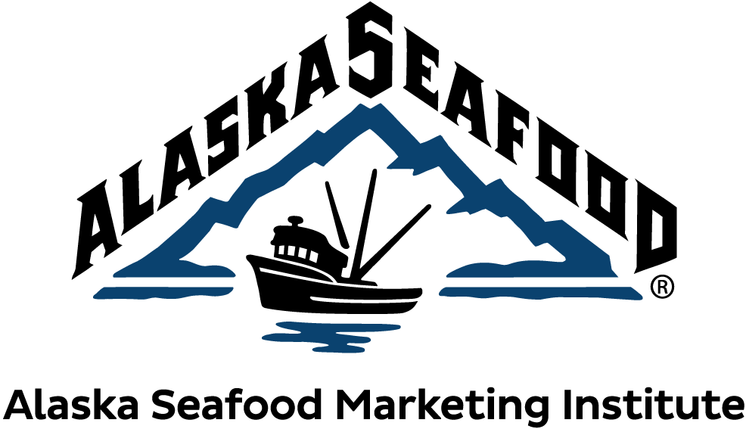

Communications Committee Meeting
Friday, August 20, 2021
9:30 AM – 11:30 AM Alaska Time

Meeting Link: https://us02web.zoom.us/j/87511537432
Meeting ID: 881 8276 8491
Call in: +1 346 248 7799 US

- 9:30 AM: Call to Order
- Roll Call
Members present: Pat Shanahan, Cassandra Squibb, Jessica Hathaway, Nicole Kimball, Peggy Parker, Julianne Curry, Matt Carle

Members absent: Hannah Heimbuch, Jack Schultheis (ex-officio), Tomi Marsh (ex-officio)

Other Attendees: Ashley Heimbigner, Arianna Elnes, Tanna Peters, Jeremy Woodrow, Megan Rider, John Burrows, Susan Marks, Hannah Lindoff, Marie Molde, Katie Goldberg, Christine Fanning, Kate Consenstein

- ASMI Antitrust Statement
Shanahan read the antitrust statement.

- Approval of Agenda
Curry motioned, Carle seconded the approval of the agenda.

- Approval of Previous Minutes
Squibb noted a typo that required clarification.
Parker motioned, Squibb seconded the approval of the minutes pending this change.
- Public Comment - There was no public comment.

- Program updates
  - Staffing update
    - Heimbigner Maternity Leave: Heimbigner gave an update on her maternity leave, and let the committee know that the Communications program was in good hands for her departure. Heimbigner would be out beginning Aug. 30, returning part time before All Hands, and full time at the beginning of Jan. 2022.
    - Sara Truitt announced her departure from ASMI beginning Sept. 1. A quick recruitment for her replacement was anticipated.
    - ASMI welcomed new employees Abi Spofford and Kara Hollatz to the International program.
    - ASMI also welcomed Amy Spencer, new Assistant coordinator to the Domestic program and announced Leah Krafft’s promotion to Foodservice Coordinator.
    - Jeremy Woodrow provided board update that Tom Enlow would not be renewing his board seat, and the governor reappointed Richard Riggs to fill his seat.
  - ASMI funding update - Jeremy Woodrow
    - Woodrow gave an update on the CARES + ARPA (American Relief Plan Act) federal funding awarded to ASMI. The governor allocated $3 million in CARES Act COVID relief funding to mitigate the economic impact of the pandemic on ASMI and our industry. In addition, the Alaska Senate Finance committee recommended that ASMI receive $20 million of ARPA funding, which was reduced to $10 million in conference committee. The $10 million was passed in the legislative budget, however, given the governor’s award of $3 million in CARES funds, the $10 million in ARPA was reduced to $7 million for a combined total of $10 million of federal COVID-19 relief to ASMI.
Woodrow anticipated another opportunity to request more ARPA funding for the Alaska seafood industry and others.
The ARPA funding will allow ASMI to address some immediate needs in the industry. It also allows ASMI some fiscal stability following record low ex-vessel pricing, the primary funding source for the organization.
Woodrow gave kudos to the ASMI teams and directors who worked hard during the legislative session to get decision makers the information they needed.
  - All Hands Update
    - Woodrow explained that with COVID-19 ramping back up, he was having conversations with the board about whether All Hands should be held virtually or in person.
  - COVID-19 Reporting
    - Recap and FY22 approach: Heimbigner noted ASMI has been reporting with McKinley Research Group on COVID-19, and will continue to do so. The 2022 economic impact report is underway, and there should be a draft for committee review in November. The economic impact report is based on a two-year average, and given that year ‘19 and ‘20 were of course very different years, ASMI would work with McKinley to talk about how to tell that story.
    - Kimball asked Heimbigner at what point the committee would be able to review: whether it would be suggestions beforehand, or reviewing a draft. Heimbigner said that both would be beneficial.
    - Kimball also asked about an economic impact review timeline, and when they could expect to see a draft. Heimbigner answered at the end of November.
    - Squibb asked about the processor and harvester surveys. She said that there was maybe a one or two percent harvester response, and wondered how we could increase the harvester response. Heimbigner said that in the report it’s noted that it’s not an exact representation, and that ASMI would want to set some higher goals in terms of representation for future surveys
  - Pacific Marine Expo - current plans:
    - Elnes gave an update on ASMI’s participatory plans for PME. She said that at this point ASMI plans to attend in person, but is keeping an eye on COVID-19 and ready to go virtual if need be.
  - Recap of Q4 Consumer PR Sustainability campaign:
    - Heimbigner noted the sustainability campaign report created by Edelman was provided in the meeting materials. The campaign included a series of long form social posts which took a deeper dive on sustainability and full transparency.
  - Direct Marketing Resources Update
    - Elnes gave a short presentation on the Direct Marketer resources. She shared with the committee that the communications program had updated the Direct Marketer webpage, created a quarterly email, reprinted 13 Eat Alaska recipe cards, and created a “Keep Frozen” sticker and “Thank You” card, which are available in KP.
  - New website preview
    - Peters gave an update on the website. She said that the communications program had worked with Sitecrafting to go through an intense research process before creating the new site. Highlights of the new site include:
      - One single content hub, combining both consumer and industry sites
      - Mobile-friendly interface
      - Two levels of navigation: main level meets both industry and consumer needs
      - Second level industry navigation, plus new industry hub
      - Easier access to tools, news, events and resources
      - Refreshed Recipe Library - made to work with Google recipes
    - Parker asked if there was a “Breaking News” feature. Peters answered there is a Media tab, as well as a News page with latest news and featured news. It is one click to the media tab, and “Latest News” and “Press Releases” section.
    - Peters invited the committee to provide feedback via the form provided and the link on the website. She stressed that the team was looking for feedback regarding things that are difficult to find or user experience issues, and asked for feedback within the next couple weeks.

- Brief presentation from Datassential on new Consumer Research
  - Heimbigner introduced Marie Molde from Datassential.
  - Molde gave a presentation on Alaska Seafood at retail, which looked at 1,000 seafood consumers surveyed.
  - Heimbigner noted that Molde’s presentation and the related sales tool publication created by the Domestic program was included in the meeting materials folder.

- Review of FY22 Consumer PR Plan and Strategy
  - Katie Goldberg of Edelman PR gave a presentation on the FY22 Consumer PR Plan and Strategy
    - Goldberg went over the FY22 Consumer PR Plan and Strategy. FY21 was a really great year for Alaska Seafood and storytelling. Consumers were buying more seafood, and they wanted to be more knowledgeable about it. ASMI’s goal is to be able to provide that moving forward. Goldberg noted an increased amount of chatter and consumer confusion around sustainability and that there was room for ASMI to create a positive narrative for Alaska seafood and position Alaska Seafood as the ideal, trusted choice.
    - FY22’s programming will focus on nutrition and wellness, culinary and origin/sustainability. The messages will be delivered through third party advocates for greater authenticity consumer trust.
    - When things are more stable, ASMI will include media dn influencer FAM trips into the programming.
  - Kimball asked how we were distinguishing ourselves from plant-based when we get lumped into the same sort of attributes. Goldberg answered that that is a great thing to lean on our RD’s to message. Before, we got a lot of questions of farmed vs. wild. Goldberg offered to share Edelman research on where we the two proteins compare and contrast.
  - Kimball also asked about the trust slide, and where the drop in trust was. Was the lack of trust in the brand, or the government? Goldberg clarified that the lack of trust was in the global food system in general, and that it’s related to government, supply chain, racial issues, gender equity, etc. that got bundled up into this massive ball of skepticism.

- Domestic Program Update
- Megan gave an update on the Domestic Program. She welcomed Amy Spencer to her team, formerly of the Alaska Lt. Governor’s office.
- The foodservice program established a new partnership with Sodexo Their goal is to be menuing 100% sustainable seafood by 2025.
- Domestic also has new bowl recipes created by Chef Keith Brunell of Nordstrom. Published materials would be available soon.
- Foodservice, along with the International and Communications program partnered with 50 Best Restaurants. They provided them short reels with Chef Justin Sutherland and Chef Barton Seaver.
- They partnered with Chef Barton Seaver at Stony Brook University to reach GenZ consumers.
- Domestic commissioned research from Datassential (as previously presented), and created a sales tool to share bite-sized stats with retail partners.
- They are also partnering with shoppable recipe platform, Chicory, to partner with Target; they have seen great results.

- Technical Program Update
- Burrows gave an update that the technical program had completed an update of several resources, including the Alaska Seafood 101 guide, Bleeding Guidelines, three species factsheets, a frozen seafood quality brochure, and were producing upcoming factsheets on mentaiko and nematodes (with Alaska Sea Grant). They have other new projects in the works.
- The technical program is also involved in trade education and regulatory efforts, including federal or organizational comments on various topics, updating and creating talking points on technical topics, and they are currently working on an article for National Fisherman on traceability, coordinated by the communications program.
- Technical is a part of an applied investigation, including a NOAA SK Grant which is putting together a Nutrient and Contaminants Database. They are a part of the advisory committee for another SK Grant awarded to Oregon State University looking at consumer acceptance of frozen seafood over the course of its shelf life. They are also nearly finished with an ongoing UCONN Breast Cancer Study, looking at gut microbiomes and salmon consumption in breast cancer survivors.
- Kimball asked about the SK Grant for the Nutrient Database, and if the intent was for it to be a long term database. Burrows said that the data would be submitted to a federal database and the idea is that you would be able to search for a specific species. The contaminant pieces are part of the monitoring program and state specific, but the nutrition part is federal. Kimball noted for everyone’s awareness that the contaminant part would require state funding long term.

- All Hands Planning and Next Meeting
- Shanahan proposed that communications and domestic have a joint meeting at All Hands similar to the 2020 event.
- She also proposed that the committee look at the questions and provide written beforehand so that they can have a meaningful discussion and use the time in the meeting to refine responses to present meaningful answers to the board. Shanahan suggested that the committee receive the questions two weeks before the meeting. The committee agreed.
- Curry asked if there would be an opportunity to bring up thoughts that had occurred during All Hands. Shanahan said yes, and that by getting the questions beforehand she thought there would be more time for that.
- It was noted that the next committee meeting would be at Alyeska Resort, Nov 8-11, unless held virtually.

- Old Business & Good of the Order
There was no old business.
Curry motioned, and Parker seconded to adjourn.
- The meeting was adjourned at 11:30am

