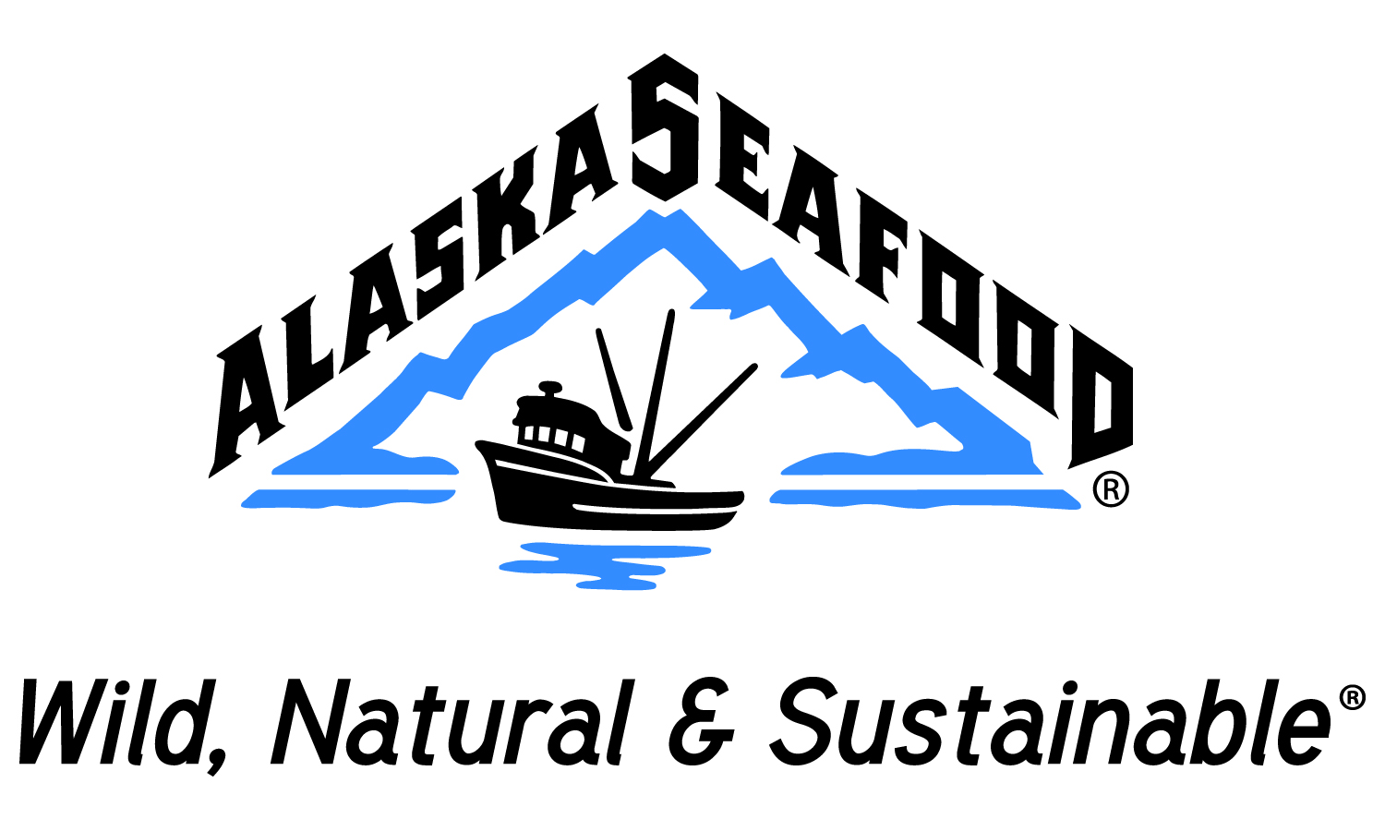
Alaska Seafood Marketing Institute
Customer Advisory Panel and Board of Directors Meeting
July 1-2 Naknek, Alaska
Draft Minutes
Tuesday, July 1
The meeting was called to order at 8:58 AM.
Chairman Kevin Adams welcomed everyone to the Bristol Bay fishing grounds.
In attendance Board Members: Chairman Kevin Adams, John Garner, Amy Humphries, Barry Collier, sitting in for John Moller – Stefanie Moreland
CAP members present: Wade Weistling, Sarah cooper, Keith Harris, Ghao Linming, Jerry Iwasa, Jeremy Langley, Dave Melbourne, David Long
Others present: Mike Cerne, Deb Tempel, Larry Andrews, Claudia Hogue, Becky Monagle, Tyson Fick, Nicole Stangeland, Alexa Tonkovich, Bruce Schactler, Dave Benton, Andy Wink, Sue Aspelund, Adelheid Herrman, Mayor Daniel O’Hara, Congressman Don Young, Elizabeth Herendeen, Glenn Reed, Tom Sunderland, Spirit Angasan, Shawna Thoma, John Walsh, and Lucy Goode.
Approval of Agenda & Minutes from April Board of Directors meeting: An amendment was made by Amy Humpherys, Fifth to the last paragraph to read: Up to an additional $250,000.00 to achieve the boards directives related to the establishment of the RFM Task Force outlined above.
A motion was made by Barry Collier, seconded by Amy Humpherys, and passed unanimously to approve the amended minutes.
Public Comment:
Sue Aspelund, Executive Director - Bristol Bay Regional Seafood Development Association (BBRSDA), she introduced their marketing director Elizabeth Herendeen. She let the group know that they would be available for any questions or collaboration that might come up.
Adelheid Herrman - Southwest Alaska Vocational & Education Center – welcomed ASMI to Bristol Bay and gave an overview of what is offered at the center for the fishing industry. She let the group know that she would be available for any questions.
ASMI program overview and update – Executive Director Mike Cerne – Made staff introductions, gave an overview of the budget, main events and happenings with ASMI. Gave quick overview of ASMI programs, some of the challenges and successes that have come up in the past year.
Status of AK Fisheries Report – Andy Wink - McDowell Group – Andy gave a through overview of the Status of Alaska fisheries.
CAP Member Presentations –
Jeremy Ryland Langley, Specialist Buyer, Fish & Shellfish, Waitrose Ltd, United Kingdom.
Waitrose is not the largest chain; it owns 12.5% of the seafood market in the UK and has grown this sector by 20% per year for the past 10 years. This growth rate is expected to continue. The readymade meals are taking off in the EU, thus getting people over the fear of cooking seafood, one of our largest obstacles according to consumer research. Promotions such as the Waitrose “garnish and go” and Saucy Fish Company has seen exponential growth. In regards to third party certification schemes, it is important to Waitrose and they recognize the MSC and FAO standards, Waitrose has their own technical committee. They have partnered with a U.S. based company who indicated they are using the same marketing tactic in the US very successfully.
Jerry Iwasa, Counselor, Kibun Foods Inc Tokyo, Japan
Jerry made mention that the State of Alaska has tested the Alaska harvest and has declared that the fish are radiation free. He is very glad that the state has made this a priority, and that the fish are free of radiation. Kibun Foods has had great success with mixing ingredients with surimi (ie: cheese, vegetables) for a readymade meal. Herring is very popular in Japan, especially marinated. Jerry summarized the history of Kibun Foods and where they have been and where they are going.
Sarah Cooper, Product Manager – Seafood & Poultry, Gordon Food Service
Gordon Food Service is in both the Foodservice and Retail business. Gordon offers many different products to the consumer, and believes that the consumer when educated will make the decision to buy wild fish. The more awareness, information, and tools we can provide the consumer the more that they will demand Alaska seafood as a brand. She recommends that we come up with “kits” to give to schools/school districts to promote seafood to kids.
Mayor Dan O’Hara, Bristol Bay Borough
Mayor O’Hara thanked all for attending this meeting in King Salmon and Naknek. He emphasized the importance of ASMI and Alaska seafood to the region.
Wade Weistling, VP of Culinary Development, Landrys, The Oceanaire Seafood Room/Morton’s Steakhouse
Wade gave a history of Landrys and the different things that they do to promote Alaska seafood. He emphasized the importance of having all staff from waiting staff to chefs to know the product intimately. Wade gave the year overview of the promotion calendar. They emphasize the use of wild fish in season as a marketing tool versus a sourcing challenge. “Get it while it’s fresh!”
Ghao Linming, General Manager, Everfish International Ltd., Qingdao, China.
Ghao gave an overview of Everfish International. He shared that traceability will become a rapidly growing concern in China. China market likes to buy whole fish, 400-600 grams is the most popular size. He stressed the importance of “telling the Alaska story” as a very successful marketing tool in China and this has become expected in the Chinese marketplace. On line shopping has taken off in China, the last promotion that included seafood sold 50 tons of Alaska seafood. Ghao would like to see more ASMI materials translated into Chinese.

Dave Melbourne, SVP Consumer Marketing and Corporate Social Responsibility, Bumble Bee Foods, LLC
Emphasized the importance of getting the message of the health benefits to Millennials; ASMI needs to hit the digital arena hard. Social responsibility and sustainability needs to remain at the forefront. The canned fish markets/product needs to be reinvented, we need to address skin and bone issues, and the nutritional value needs to be stressed. Communicate with the buyers, educating the consumer; recipes are the number one thing a consumer is looking for. We need to dumb down the RFM so that the general public can understand its importance, give your buyers talking points that everybody can understand.
Congressman Don Young
Spoke in regards to regulations at the federal level in regards Alaska salmon. The importance of promoting sustainability and educating the consumer on how to cook seafood. Charged the group to keep up the good work at ASMI on promoting seafood.
Keith Harris, Seafood buyer, Whole Foods Market
Keith gave an overview of Whole Foods markets and who their market is. The consumer loves the “fisherman’s story”. He encourages ASMI to help the direct marketer with education, he sees a lot of them struggling trying to get their product to the market.
David Long, Seafood Coordinator, Kroger Company

Dave emphasized the importance to making fish easy to cook. Continually educating the world especially Millennials with why they should be eating seafood, and giving them the knowledge so that they demand Alaska seafood. Hitting social media is where marketing monies need to go. They started giving money back guarantee on seafood purchases; this has brought in new customers.
Items that came up from multiple CAP members:
- Continue to proved recipes, imagery, training (Seafood U), and incentives to our Foodservice industry.
- Stay engaged with GSSI process as it moves forward.
- Social media, social media, and more social media.
- Canned fish market/product needs to be reinvented, skin and bone needs to be addressed.
- Readymade meals are an easy way to get new consumers and put meals on the table fast.
- The fishing family story is important and is a great marketing tool.
RFM Conformance Criteria Committee
Michael Cerne Executive Director and Dave Benton contractor gave a recap on the Responsible Fisheries Management Taskforce. The discussion included, the importance of this taskforce is that we are able to convey the information in a clear concise message that is easy to understand. CAP members offered help in the process because this has been done before. Members of the taskforce stressed that they are committed to its success. It was stressed that communications be consistent, concise, and simple.
Collaboration between ASMI Staff, BOD and CAP members
- Social media in many different forms all day long
- Get people talking about Alaska seafood and its benefits
- Get Alaska seafood in the quick service restaurants
- Get fresh or fresh/frozen Alaska seafood in wholesale retailers
- Educate the consumer, and make it easier to prepare and cook seafood
- A discussion re: social responsibility and the industry concluded that everybody wants health and safety for seafood industry workers around the world
- E-Commerce is a booming huge new market for retailers
- Share the story behind the product, fishing families, about the location it was harvested
- Increase cooler/freezer space at major airports
- Be innovative in the canned salmon, it is necessary to attract new consumers
- Get in the school lunch program, make it cool, get great products in their mouth
- Get national chains pushing seafood
- Increase use of short videos, important to attracting the Millennials
Charge to the staff: At the next board meeting a recommendation to the board on how ASMI can better perform in social media.
Submitted by Deb Tempel

