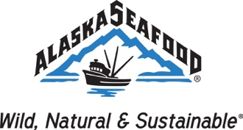

2021 ASMI All Hands on Deck
Key Questions for Species Committees

- What are the top 3 opportunities you see for your species in international markets?

- What are the top 3 opportunities you see for your species in the US domestic market?

- Please identify any areas where ASMI may be able to provide technical support for your species, i.e., quality, products, packaging, health, safety, nutritional.

- For your species, what issues or topics (if any) can ASMI help with messaging and/or outreach?

- What challenges/threats do you anticipate for your species in the next year or near future?

